Breaking the Cycle of Malnutrition

Breaking the Cycle: Infants and Young Children
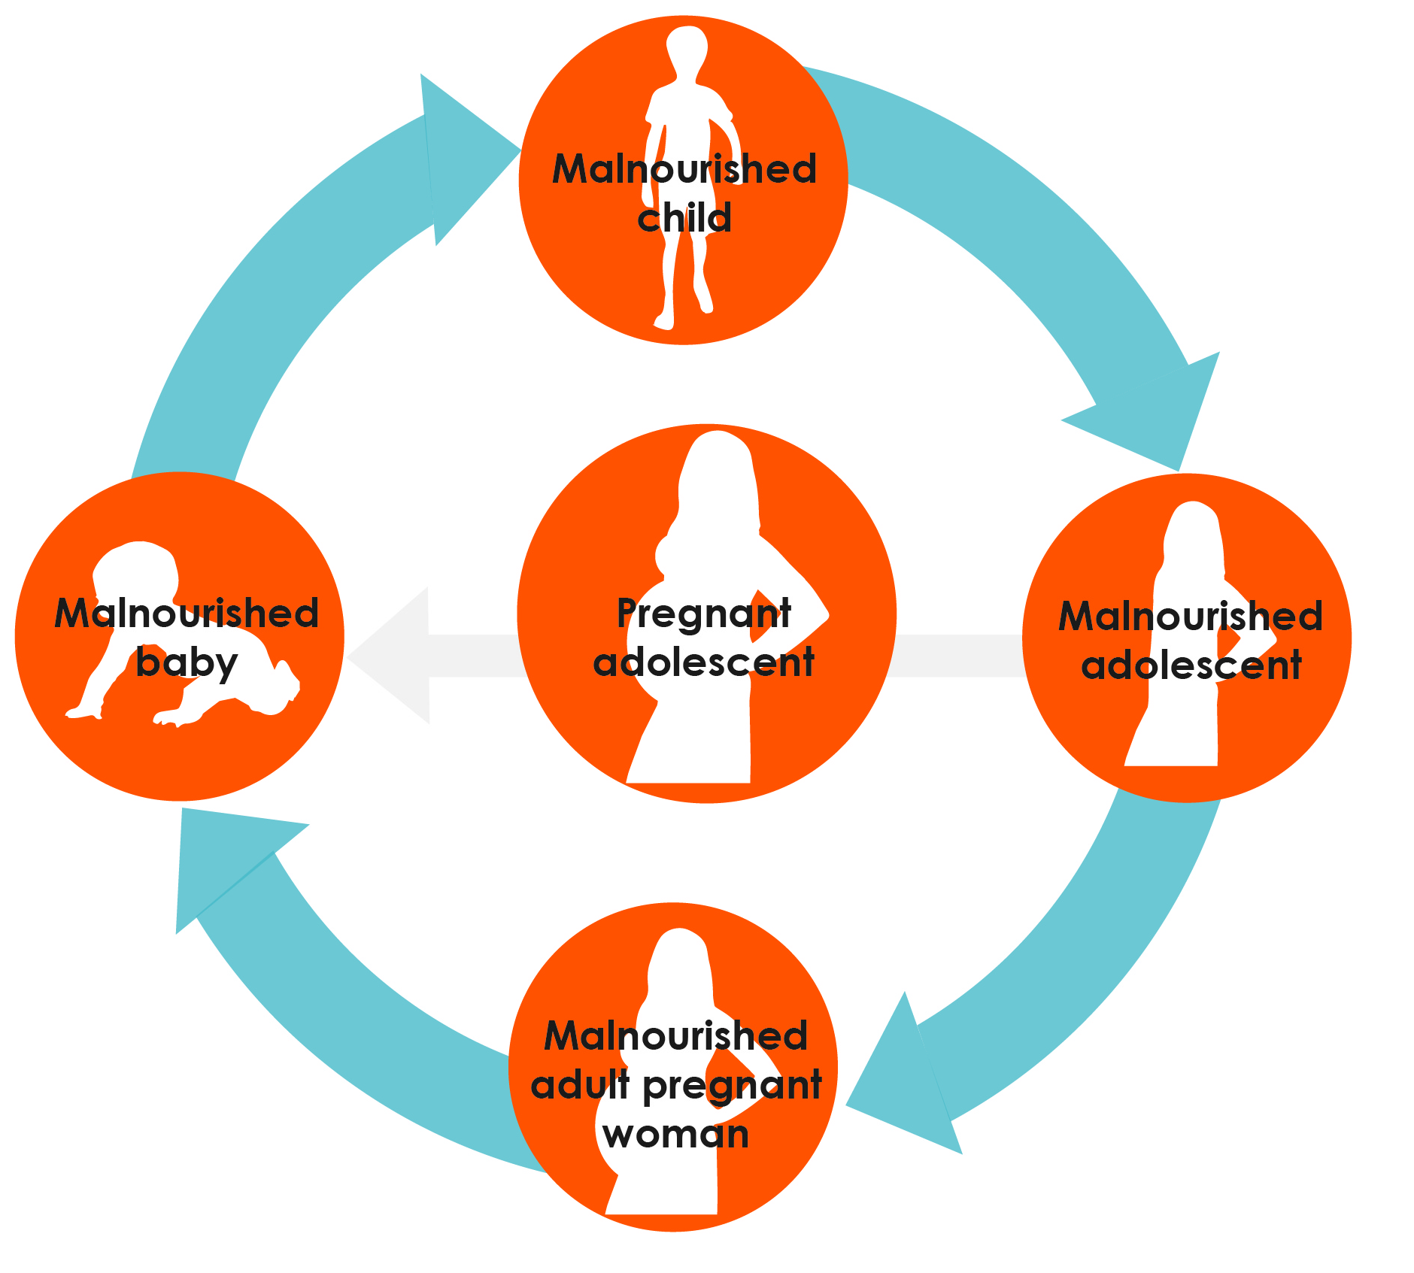
- Encourage early initiation of breastfeeding, within 1 hour of birth. This helps establish breastfeeding practices early on, and ensures that babies receive colostrum, the “first milk” which is full of nutrients and antibodies to give babies the best start in life.
- Practice exclusive breastfeeding until the child is 6 months. Exclusive breastfeeding means that no other foods or fluids are given to the baby, except for needed medicines.
- Encouraging timely introduction of complementary foods at 6 months, with continuation of breastfeeding up to 2 years or beyond. (Again, no other food is needed during the first 6 months.)
- Sick children require extra food and fluids to help them recover, and should be fed frequently during illness, and for 2 weeks after recovery.
- Children with severe acute malnutrition are at immediate risk of mortality and should be taken to a health facility for assessment and treatment. Most of these children can then be treated at home using special therapeutic foods.
- For the mother, using iodized salt in place of regular (non-iodized) salt helps ensure that the breastfeeding infant gets iodine, which is important for cognitive growth and development.
- Other “non-feeding” actions:
  - The mother should attend growth monitoring, promotion and immunization sessions.
  - Pregnant women and children should use insecticide-treated nets (ITNs) in areas where malaria infection occurs
  - Regular clinic visits for prevention and timely detection and treatment of common illnesses such as pneumonia, diarrhea, and malaria, including deworming.
  - Vitamin A supplementation.

Breaking the Cycle: Adolescence
- Increasing food intake: Teenage girls need to eat at every meal. Make sure they eat.
- Encouraging parents to give girls and boys equal access to education. Undernutrition decreases when girls and women receive more education.
- Encouraging families to delay marriage for young girls.
- Delaying first pregnancy until the mother’s own growth is completed (usually 20–24 years of age) will help to reduce complications for the infant and mother.

Breaking the Cycle: Adulthood
- Visiting a family planning center to discuss which family planning methods are available and most appropriate for the individual’s situation. (Using a family planning method is important to adequately space births.)
- Ensuring eight health system antenatal contacts. Updated WHO guidelines increased the recommended number of contacts a pregnant woman should have during her pregnancy from 4 to 8 because of evidence that additional visits/contact reduces the risk of stillbirth. Antenatal care is a critical opportunity for health providers to deliver care, support and information to pregnant women.
- Increasing food intake during pregnancy and breastfeeding. During pregnancy this means eating one extra meal or “snack” (food between meals) each day; during breastfeeding, it means eating two extra meals or “snacks” each day.
- Taking iron/folate supplementation (or other recommended supplements for pregnant women) as soon as she knows she is pregnant and continuing for at least 3 months after delivery of the child, according to national recommendations.
- Deworming and giving antimalarial drugs to pregnant women at 4 and more months of pregnancy.
- Prevention, education, and testing for sexually transmitted infections (STIs), including HIV.
- Letting other members of the family help with the pregnant woman’s workload.
- Resting more, especially during late pregnancy.

Breaking the Cycle: At Every Stage of Life
- In addition, there are some general practices that should be practiced at every stage of life.
- Eat a diet from a diverse range of sources. Families should aim to provide children foods from four or more food groups each day, and eat a range of healthy foods throughout the week.
  - Animal-source foods such as chicken, fish, liver, eggs, milk, and milk products. (Note: animal-source foods should be started at 6 months.)
  - Staples: Grains such as maize, rice millet, and sorghum; roots and tubers such as cassava and potatoes.
  - Legumes such as beans, lentils, peas, and groundnuts; seeds such as sesame.
  - Fruits and vegetables rich in vitamin A, such as mango, papaya, passion fruit, oranges, dark-green leaves, carrots, sweet potato, pumpkin; and other fruits and vegetables, such as banana, pineapple, watermelon, tomatoes, avocado, eggplant and cabbage.
  - Oil and fats, such as oil seeds, margarine, ghee, and butter added to vegetables, and other foods will improve the absorption of some vitamins and provide extra energy. Infants need only a very small amount (no more than half a teaspoon per day).
- Practice appropriate hygiene, such as using latrines, keeping food and water containers clean, and washing hands before eating or preparing meals.
- Prevent and seek treatment for infections early.

Other Family Members Help Break the Cycle
- How can husbands/partners help break the cycle of malnutrition?
  - Provide extra food for their wives/partners during pregnancy and lactation.
  - Help with household chores to reduce wives’/partners’ workload.
  - Encourage their wives/partners deliver the baby at health facility.
  - Make arrangements for safe transportation to facility (if needed) for birth.
  - Encourage their wives/partners to breastfeed immediately after birth and to continue to breastfeed, even in light of other household and farm responsibilities
  - Discuss options for family planning together with their wives/partners.
  - Encourage equal access to education for girls and boys.
  - Accompany their wives/partners to antenatal care and remind them to take their iron/folate tablets.
- How can female elders (mothers, grandmothers, in-laws) participate in breaking the malnutrition cycle for women and children?
  - Accompany the pregnant woman to antenatal care and remind her to take her iron/folate tablets.
  - Provide extra food for the pregnant woman/new mother during pregnancy and lactation.
  - Help with the pregnant woman/new mother with household chores to reduce her workload.
  - Encourage the pregnant woman to deliver at health facility.
  - Encourage breastfeeding immediately after birth, and provide continued support to mothers to exclusively breastfeed for the first six months.

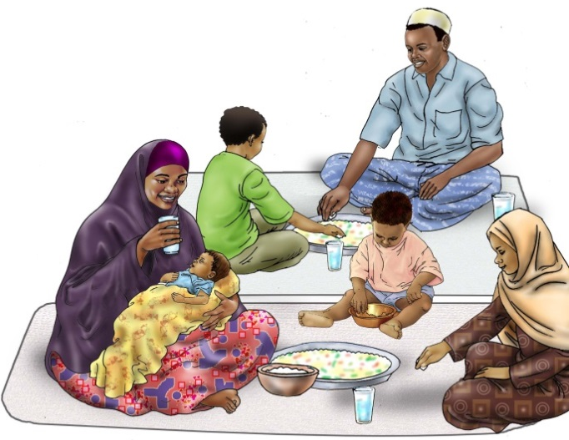

World Health Organization. WHO Recommendations on Antenatal Care for a Positive Pregnancy Experience. Geneva : WHO. 2016.

