Strengthening Agriculture-Nutrition Linkages: Why It Matters
Session Guide One of the Nutrition-Sensitive Agriculture Training Resource Package
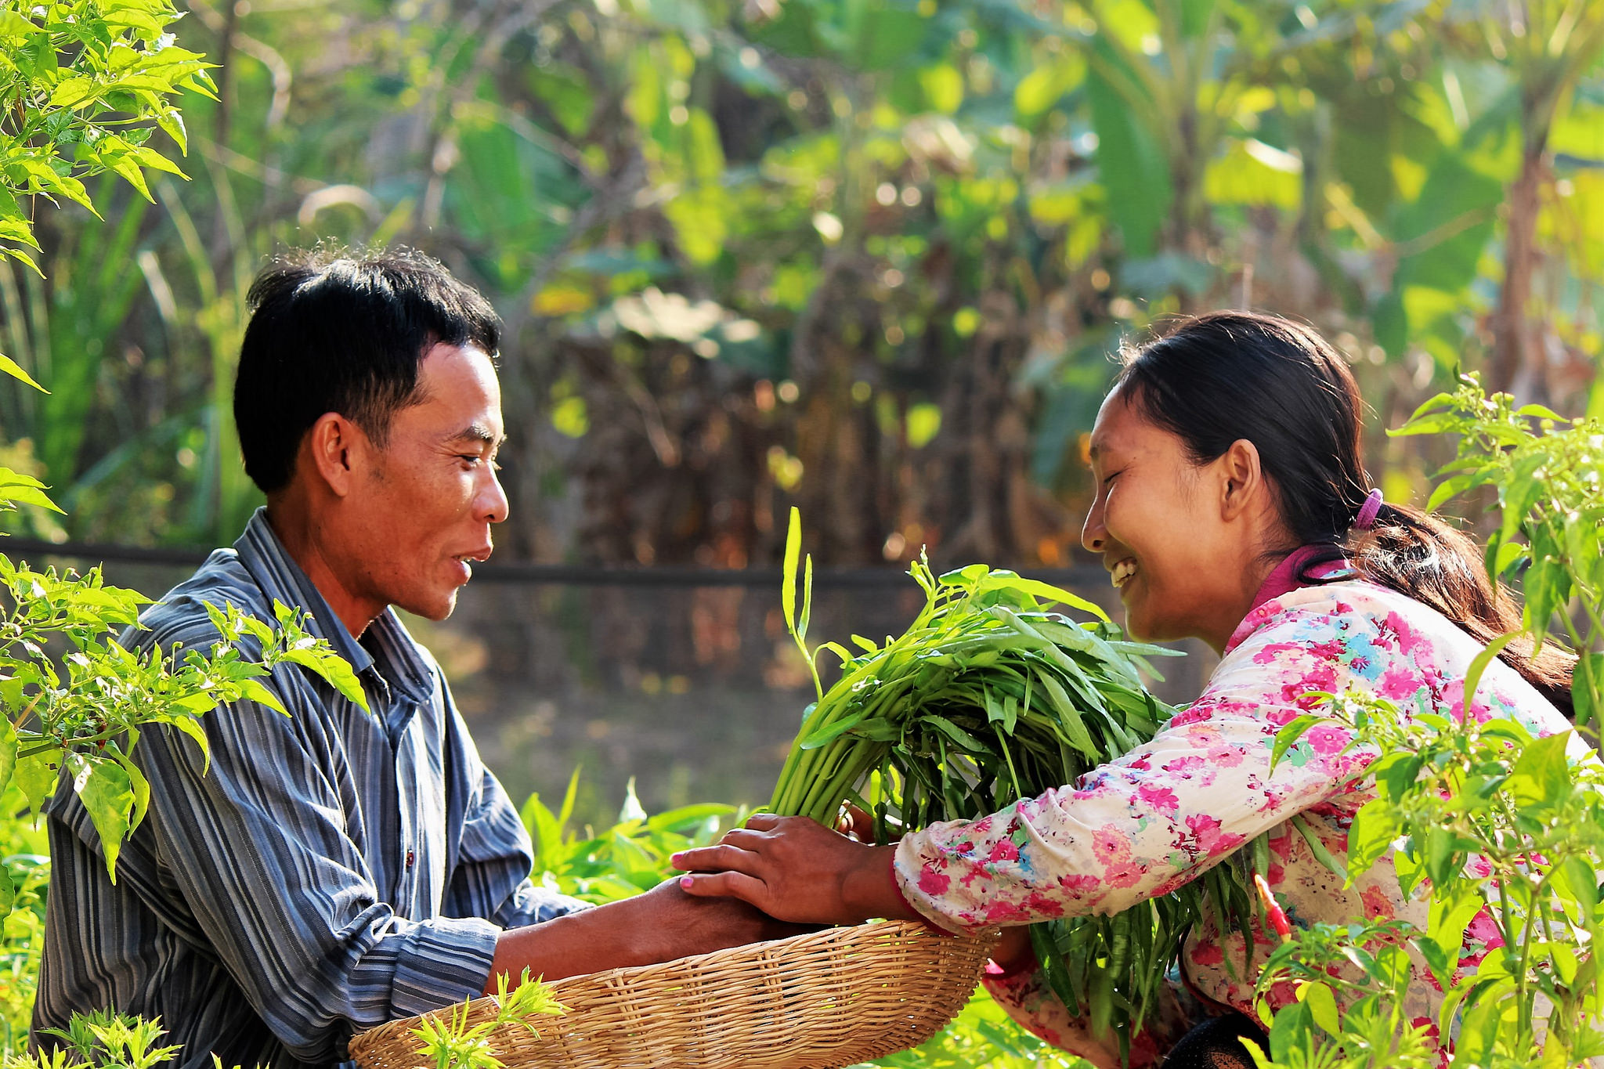

Strengthening Agriculture-Nutrition Linkages: Why It Matters
Session Guide One of the Nutrition-Sensitive Agriculture Training Resource Package

ABOUT SPRING
The Strengthening Partnerships, Results, and Innovations in Nutrition Globally (SPRING) project is a seven-year USAID-funded cooperative agreement to strengthen global and country efforts to scale up high-impact nutrition practices and policies and improve maternal and child nutrition outcomes. The project is managed by JSI Research & Training Institute, Inc., with partners Helen Keller International, The Manoff Group, Save the Children, and the International Food Policy Research Institute.
RECOMMENDED CITATION
SPRING. 2018. Strengthening Agriculture-Nutrition Linkages: Why It Matters. Session Guide One of the Nutrition-Sensitive Agriculture Training Resource Package. Arlington, VA: Strengthening Partnerships, Results, and Innovations in Nutrition Globally (SPRING) project.
DISCLAIMER
This report is made possible by the generous support of the American people through the United States Agency for International Development (USAID) and Feed the Future, the U.S. Government’s global hunger and food security initiative, under the terms of the Cooperative Agreement AID-OAA-A-11-00031 (SPRING), managed by JSI Research & Training Institute, Inc. (JSI). The contents are the responsibility of JSI and the authors, and do not necessarily reflect the views of USAID or the U.S. Government.

SPRING
JSI Research & Training Institute, Inc.
1616 Fort Myer Drive, 16th Floor
Arlington, VA 22209 USA
Phone: 703-528-7474
Fax: 703-528-7480
Email: info@spring-nutrition.org
Internet: www.spring-nutrition.org

COVER PHOTOS: Farmers harvest morning glory together from their nutrient-rich home garden in Cambodia. Marie Cusick, NOURISH

Contents
Preparing to Present this Session 1
Purpose 1
Estimated Duration 1
Materials 1
Core Content 2
References 6
Additional Resources 6

Preparing to Present this Session
Purpose
This is Session One of seven included in the Nutrition-Sensitive Agriculture Training Resource Package.
This session lays the foundation for why nutrition-sensitive agriculture is important for a range of stakeholders working in livelihoods, food security, economic growth, nutrition, and maternal and child health. The content included here can be used to begin a training focused on nutrition-sensitive agriculture or as a stand-alone session for a group of high-level stakeholders. It explains why nutrition-sensitive agriculture is important and how nutrition outcomes can be reached through agricultural interventions.
By the end of this session, participants should be able to—
- articulate key information on the social and economic impact of malnutrition
- explain why a multi-sectoral approach is needed to address malnutrition
- introduce the concept of nutrition-sensitive agriculture
- outline specific ways that agriculture can support improved nutrition.
Estimated Duration
30 minutes
Materials
This session includes a presentation guide, designed with an accompanying slide set. The session guide provides detailed suggestions for how the facilitator can explain each slide, and activities to accompany each session. Before presenting this content, the facilitator should adapt the session to the specific context and audience with attribution to the SPRING project. All materials needed to deliver the session, including handouts and illustrations for activities, can be found on the SPRING website at https://www.spring-nutrition.org/nutrition-sensitive-ag-training/session1. They include:
- PowerPoint presentation: 1. Strengthening Agriculture-Nutrition Linkages: Why It Matters
- Handout: 5 Ways to Improve Nutrition through Agriculture
Core Content
Slide 1 (cover) Strengthening Agriculture-Nutrition Linkages: Why It Matters
- The linkages between agriculture and nutrition are increasingly being recognized as important for achieving global nutrition goals.
- More and more donors and programs are focusing on multi-sectoral strategies that bring together established principles, standards, and practices from agricultural market systems development and nutrition. Today, we will look at why those linkages matter.

Discuss: Ask the group what they have heard about nutrition-sensitive agriculture and what they consider to be the most important links between agriculture and nutrition. Spend a few minutes letting participants share and take several responses. If possible, clarify which of the concepts mentioned will be addressed at greater length during the workshop and which are outside the scope of what you plan to present.

Facilitator Note: If you are using this session to open a longer training about nutrition-sensitive agriculture, be sure to add a few slides here that outline your course goals. Explain why these particular participants have been selected for the workshop and what actions participants will be expected to take after the training is finished.
This session can also be used as a stand-alone presentation to help stakeholders understand why they should buy in to the idea of nutrition-sensitive agriculture. If this is your purpose, be sure to remove slide 2.

Slide 2 Nutrition-Sensitive Agriculture: The Full Program
- Today, we have brought together a diverse group of stakeholders to discuss the linkages between nutrition and agriculture. As we begin, it is important to recognize that our respective backgrounds, experiences, disciplines, and sectors give us different approaches and perspectives.
- This set of seven sessions was designed to give all stakeholders a shared vocabulary and solid understanding of key concepts underlying nutrition-sensitive agriculture. This foundation helps to ensure that we have a productive conversation that leads to concrete actions.
- Nutrition-sensitive agriculture is an approach that harnesses the best practices of agriculture and food security programs to more directly address malnutrition.
  - Before we begin, everyone involved needs to be familiar with essential nutrition and agriculture concepts.
  - After that, we introduce the Agriculture-to-Nutrition Pathways, which lay out a more detailed set of steps that link the two sectors.
  - Using the seasonal calendar, we begin to apply the pathways to a specific country context and illustrate how the pathways can be used in practice.
  - As we begin to think more strategically about the application of the pathways to real contexts, we discuss the important role of behavior change in meeting our goals.
  - Lastly, we will work together to design nutrition-sensitive agriculture programs that are aligned with the scope of our existing activities, our organizational mission(s) and the context in which we are working.
- The sessions that make up this workshop will provide us with strategies for making our agriculture work more nutrition-sensitive.

Facilitator Note: Completing all 7 sessions is estimated to take 2½ to 3½ days, including a full day and a half for the design session. After you have adapted the materials for your audience, you can determine how much time is appropriate to spend on each session. The recommended length of time is noted at the beginning of each session guide, and there is a full sample agenda in the introduction session.

Slide 3 Session Objectives
By the end of this session, participants will be able to—
- articulate key information on the social and economic impact of malnutrition
- explain why a multi-sectoral approach is needed to address malnutrition
- introduce the concept of nutrition-sensitive agriculture
- outline specific ways that agriculture can support improved nutrition.

Slide 4 Why Should the Agriculture Sector Care About Nutrition?
- Forty-five percent of child deaths are due to undernutrition (IFPRI 2016). The impact of that malnutrition—especially for a child or a pregnant woman—lasts for years and may be irreversible.
- Agriculture programs are well-positioned to have an important impact on nutrition outcomes.

Slide 5 Cost of Malnutrition
- Malnutrition causes child and maternal mortality. Malnutrition also causes illness, with underweight being the number one contributor to the burden of disease in sub-Saharan Africa.
- Because malnutrition leads to an overall lower intelligence quotient (IQ) and reduced school performance, malnutrition can have significant economic ramifications in the form of reduced work productivity and earnings.
- Countries across Asia and Africa lose 11 percent of gross national product every year because of poor nutrition.
(Black et al. 2013; Lim et al. 2012; Steckel 2013; IFPRI 2016.)
Facilitator Note: These slides give a focused overview of the costs of malnutrition. More resources that explore malnutrition in greater depth are available. You will find a selection of useful articles and documents included with Session Two (Essential Nutrition Concepts) of this Training Resource Package. A list of additional resources can be found at the end of each session guide.

Slide 6 Improved Nutrition Drives Economic Growth
- Improving nutrition can drive economic growth for the family and for the country.
- In several African countries studied, every US$1 invested in reducing chronic undernutrition in children, yields an estimated US$16 return in increased capacity and productivity (Hoddinott 2016).

Slide 7 What Works to Reduce Undernutrition? Nutrition-Specific Interventions
- Decades of programming and research have led to a consensus about approaches that work best to address the immediate causes of undernutrition across countries and contexts.
- These activities and interventions include things like promoting correct breastfeeding practices and providing micronutrient supplements to pregnant women and young children. These are referred to as nutrition-specific interventions. Session Two explores nutrition-specific interventions in more detail.
- Estimates show that even if we can scale up nutrition-specific interventions to cover 90 percent of the at-risk population, it would only address about 20 percent of chronic malnutrition (Black et al. 2013). So, what more is needed?

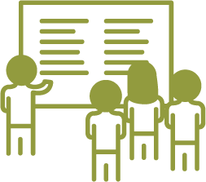 | Lessons Learned: Be sure to plan enough time to allow diverse stakeholders to get on the same page about nutrition-sensitive agriculture—it may take longer than you expect. Agriculture experts need to understand some basic nutrition concepts to discuss nutrition-sensitive agriculture effectively, while nutrition experts may need more background in agriculture. We have found that Sessions 2 and 3 are very helpful in doing this. When you bring these two groups together, you will be helping these two groups understand each other’s thinking and gain a common language that will facilitate the development of context-specific nutrition-sensitive agriculture solutions.

Slide 8 What Works to Reduce Undernutrition? Nutrition-Sensitive Interventions
- Nutrition-sensitive interventions, which address the deeper causes of malnutrition, are important for addressing the remaining 80 percent of chronic malnutrition (Black et al. 2013; Lim et al. 2012; Steckel 2013; IFPRI 2016).
- These nutrition-sensitive interventions address the underlying causes of undernutrition—food, care, and health.
  - We are talking about interventions that increase household access to diverse, nutritious foods, year-round.
  - Interventions that enable access to health services and ensure a healthy environment through appropriate water, sanitation and hygiene (WASH) strategies and activities.
  - Interventions that enable caregivers, primarily women, to provide proper care to their families, including ensuring age-appropriate feeding practices.

Slide 9 How does Agriculture Affect Nutrition?
- There are three essential linkages between agriculture and nutrition—food production, income, and gender (how women’s time and energy are spent).
  - The most obvious linkage between agriculture and nutrition is the production of nutritious foods. This is one way agriculture can contribute positively to nutrition—by making more diverse, nutritious foods available in local markets and in farmer households.
  - Households also depend on income, which they use to purchase food, health services and hygiene-related goods that are necessary to maintain good health and nutrition. It is important to note that not all household income derives from agriculture related-activities. One way to promote resiliency is to assist households with both on-farm and off-farm income-earning opportunities.
  - Women are highly engaged in agricultural activities. How women use their time and energy can have significant implications for their health and nutrition as well as the health and nutrition of their children. Women who have some control over how household income is spent tend to ensure that household income is spent on things that improve the health of the family (USAID 2017).

Facilitator Note: Hand out copies of the document, “Five Ways to Improve Nutrition through Agriculture.”

Slides 10–11 Five Ways to Improve Nutrition through Agriculture (animated slides)
- Simple answers and practices are not easy to come by in nutrition-sensitive agriculture work. Nevertheless, there are some things that we can do right now.
- These possible solutions cut across country-specific contexts and target groups. Nonetheless, any proposed interventions will need to be based on detailed context assessments.
- There will be opportunities in other sessions of this training to dig into context-specific solutions, factoring in the particular expertise and resources your activity brings to bear. This includes interactive exercises you can do as an activity team.

Slide 12 Key Points from this Session
- Good nutrition is essential for children to survive and thrive. The consequences of malnutrition are serious—45 percent of child deaths are a result of undernutrition.
- Countries pay a high price for malnutrition with decreased educational activity, productivity and earnings. Nutrition is a good investment, with a US$16 return for every dollar spent.
- Nutrition-sensitive approaches address underlying causes of malnutrition, such as food security and quality, child/family care, health services, and WASH.
- Agriculture affects nutrition in several important ways: It influences which food is consumed, how farm income is spent, how women spend their time and energy, and women’s ability to control household income.

References
Black, Robert E., Cesar G. Victora, Susan P. Walker, Zulfiqar A. Bhutta, Parul Christian, Mercedes de Onis, Majid Ezzati, et al. 2013. “Maternal and Child Undernutrition and Overweight in Low-Income and Middle-Income Countries.” The Lancet 382 (9890):427–51. https://doi.org/10.1016/S0140-6736(13)60937-X.
Lim, Stephen et al. Lim et al. 2012. “A comparative risk assessment of burden of disease and injury attributable to 67 risk factors and risk factor clusters in 21 regions, 1990–2010: a systematic analysis for the Global Burden of Disease Study 2010.” The Lancet 380(9859): 2224–2260. doi:10.1016/S0140-6736(12)61766-8.
Hoddinott, J. 2016. “The economics of reducing malnutrition in Sub-Saharan Africa,” Global Nutrition Report (May 13). Produced for the Global Panel on Agriculture and Food Systems for Nutrition. http://glopan.org/sites/default/files/Global_Panel_Working_Paper.pdf
Horton, Sue, and Richard H. Steckel. 2013. “Global Economic Losses Attributable to Malnutrition 1900–2000 and Projections to 2050.” In The Economics of Human Challenges, B. Lomborg. Cambridge, U.K.: Cambridge University Press.
International Food Policy Research Institute (IFPRI). 2016. Global Nutrition Report 2016: From Promise to Impact: Ending Malnutrition by 2030. Washington, D.C.: IFRPI. http://www.globalnutritionreport.org/the-report-2016/.
United States Agency for International Development (USAID). 2017. Multi-sectoral Nutrition Strategy 2014-2025, Technical Guidance Brief: Gender Considerations for Achieving Nutrition Outcomes through Agriculture. Washington, DC: USAID. https://www.usaid.gov/sites/default/files/documents/1864/gender-sensitive-ag-tech-guidance-brief-edit-508.pdf.

Additional Resources
The following resources provide further information about why agriculture-nutrition linkages matter:
SPRING. 2015. Context Assessment for Linking Agriculture and Nutrition. Online. https://www.spring-nutrition.org/publications/series/context-assessment-linking-agriculture-and-nutrition.
United States Agency for International Development (USAID). 2017. Multi-sectoral Nutrition Strategy 2014-2025, Technical Guidance Brief: Gender Considerations for Achieving Nutrition Outcomes through Agriculture. Washington, DC: USAID. https://www.usaid.gov/sites/default/files/documents/1864/gender-sensitive-ag-tech-guidance-brief-edit-508.pdf.

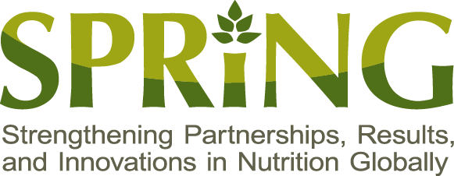
SPRING
JSI Research & Training Institute, Inc.
1616 Fort Myer Drive, 16th Floor
Arlington, VA 22209 USA
Tel: 703-528-7474
Fax: 703-528-7480
Email: info@spring-nutrition.org
Web: www.spring-nutrition.org

